**SMART STAR EXAMINATIONS BOARD**

**END OF TERM ONE EXAMINATION - 2024**

**HEALTH HABITS**

**TOP CLASS**

My name is…………………………………………

1. 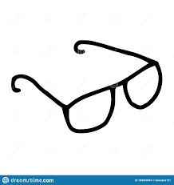**Match correctly.**

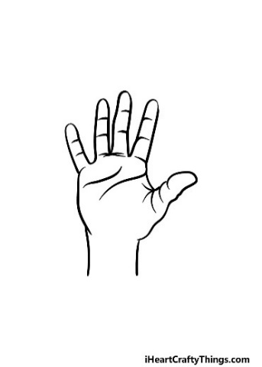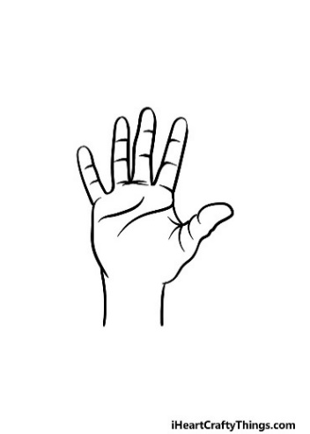

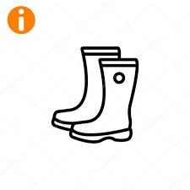 



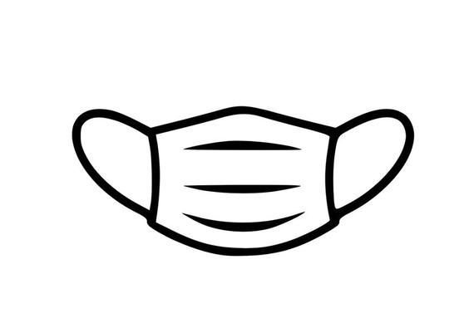

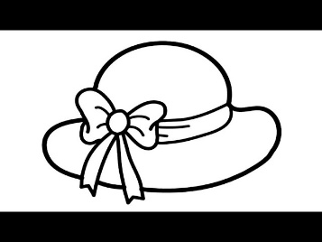



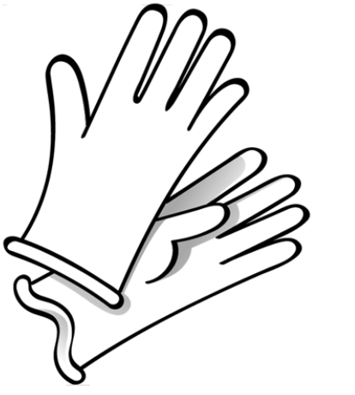

1. **Name parts of the head**.

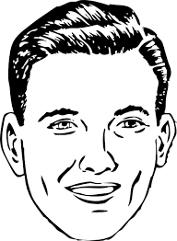

(nose, hair, ear, mouth, eye, neck)

**3. Circle the correct word**

|  |  |  |  |
| --- | --- | --- | --- |
| C:\Users\Head Teacher\Downloads\toothbrush.png | tooth | toothbrush | Toothpaste |
|  | spoon | sweet | sponge |
| **C:\Users\Beatrice\Pictures\2016-07-26\003.jpg** | toothpaste | comb | hanky |
| C:\Users\HOME\Pictures\2015-03-12\004.jpg | mask | tower | towel |

**4. Name correctly.**

|  |  |  |
| --- | --- | --- |
| How to draw a Dress Step by Step | Woman Dress Drawing Lesson - YouTube | Mens Active Sleeveless Tank Top Vest Stock Vector (Royalty Free) 2231172493  | Shutterstock | UNDERWEAR SIZE CHART — PANSY |
|  |  |  |
| sho | C:\Users\HTr-HSG\Downloads\belt.png |  |
|  |  |  |

(pant, dress, shoe, belt, vest, tie)

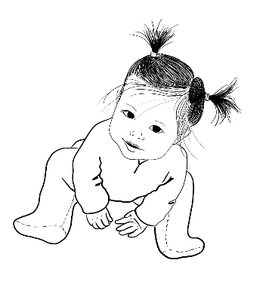**5. Match to the belonging.**

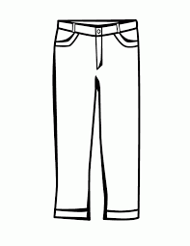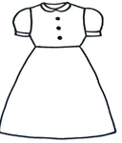

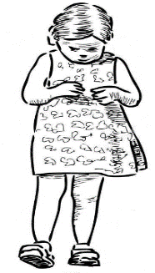

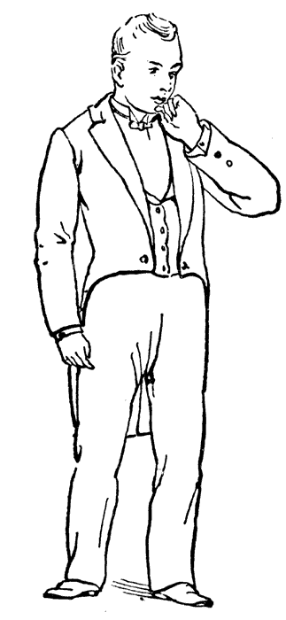

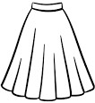

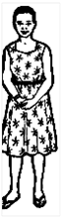

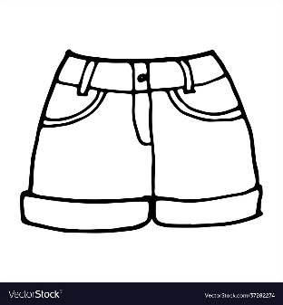

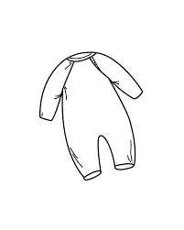

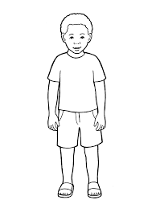

**6. Fill in the missing letters.**

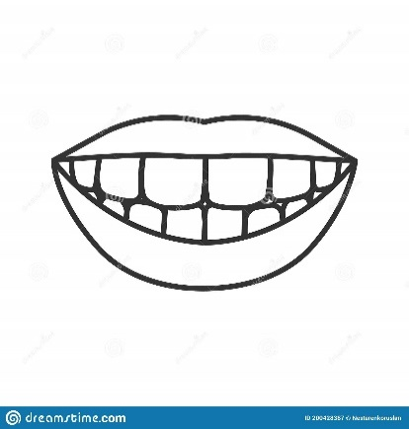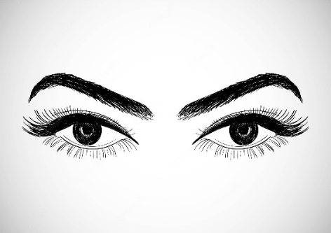e__es

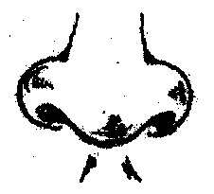__eeth

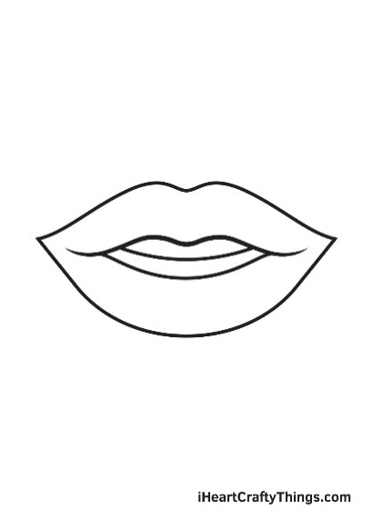

n__se mou___

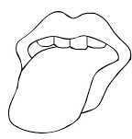

__ongue

**Oral.**

1. How many fingers do you have?
2. Why do you brush your teeth?
3. What do we do before eating food?
4. What is the use of a handkerchief? END: